Centro Educacional Brasil Portugal
Teacher: Márcia Cristine | Subject: English | Class:5° ano
Name:__________________________________________________
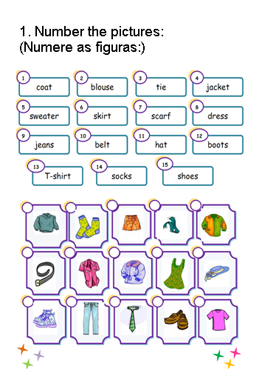
SEMANA DE 06/04 ATE/09/04

